To set up Tomcat in IntelliJ IDEA using a tarball (for example, **apache-tomcat-9.0.80.tar**), follow the steps below:

1. **Download and Extract the Tarball**: If you haven't already, download the desired version of Tomcat from the official website. Once downloaded, extract the tarball:

tar -xvf apache-tomcat-9.0.80.tar

This will create a directory named **apache-tomcat-9.0.80**.

1. **Open IntelliJ IDEA**: Start IntelliJ IDEA.
2. **Configure Tomcat as an Application Server**:
   * Click on **File** → **Settings** (or **IntelliJ IDEA** → **Preferences** on macOS).
   * In the left pane, expand the **Build, Execution, Deployment** section.
   * Click on **Application Servers**.
   * Click on the **+** button on the right side to add a new server and choose **Tomcat Server**.
   * In the **Tomcat Home** field, browse to the location where you extracted the Tomcat tarball (the **apache-tomcat-9.0.80** directory).
   * Click **OK**.
   * IntelliJ IDEA will automatically detect the Tomcat version and fill in the **Name** and other details. You can adjust these if necessary.
3. **Create a New Project (if needed)**: If you're starting a new project:
   * Click on **File** → **New** → **Project**.
   * Choose a project type (e.g., **Java Enterprise**).
   * In the **Additional Libraries and Frameworks** section, ensure that **Web Application** is checked.
   * Click **Next** and continue with the project creation steps.

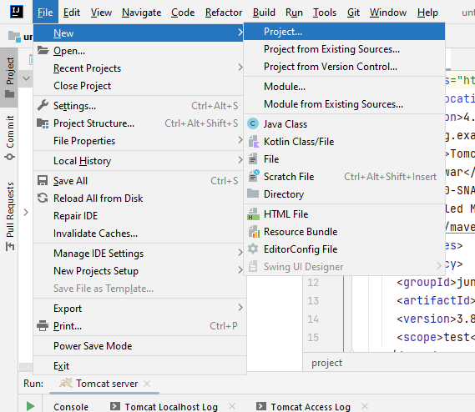

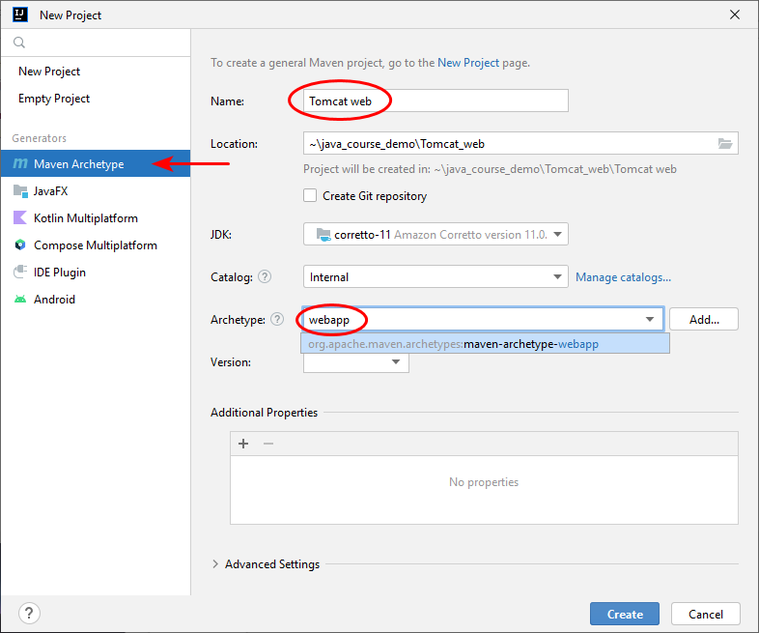

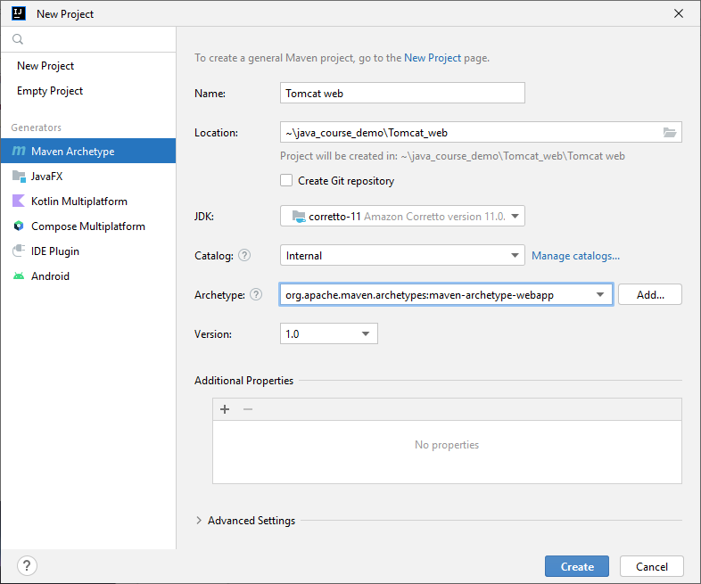

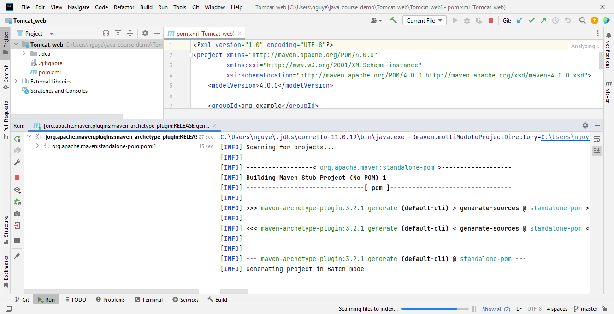

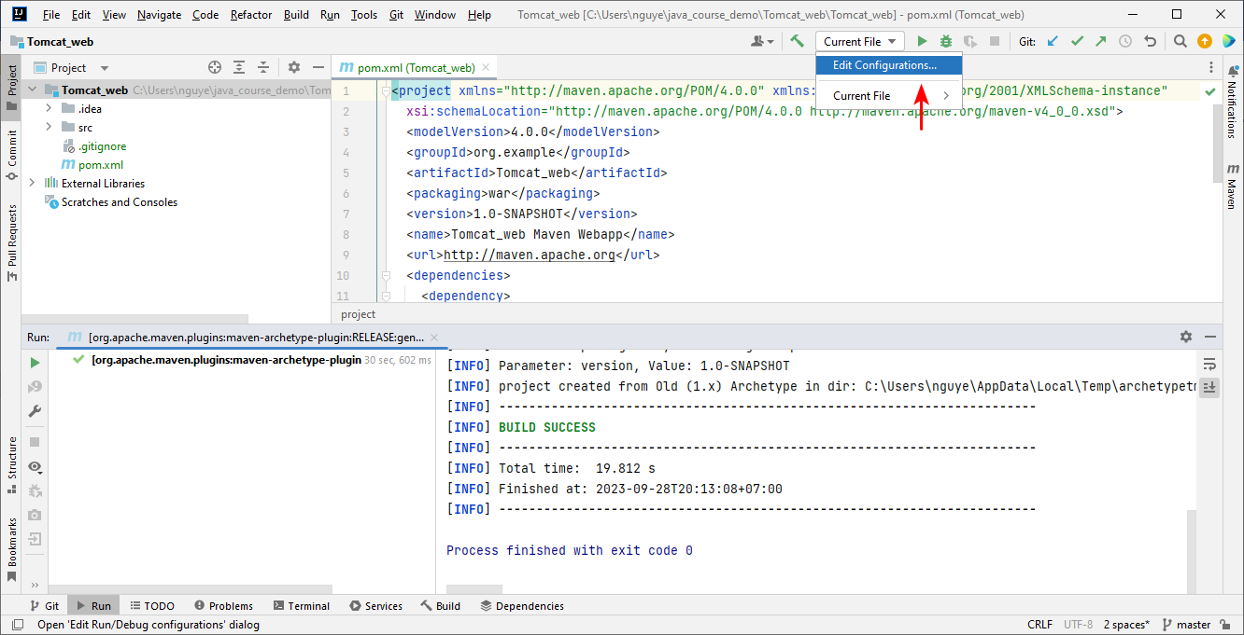

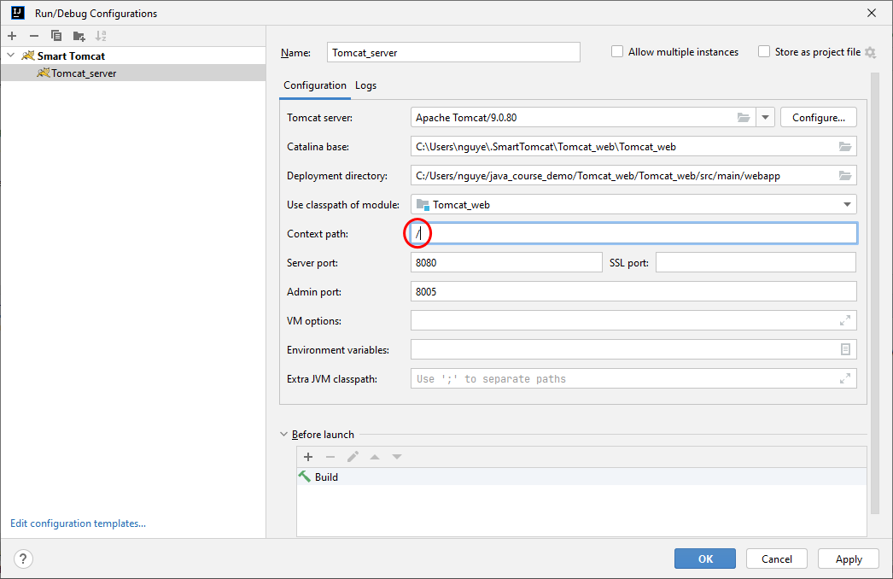

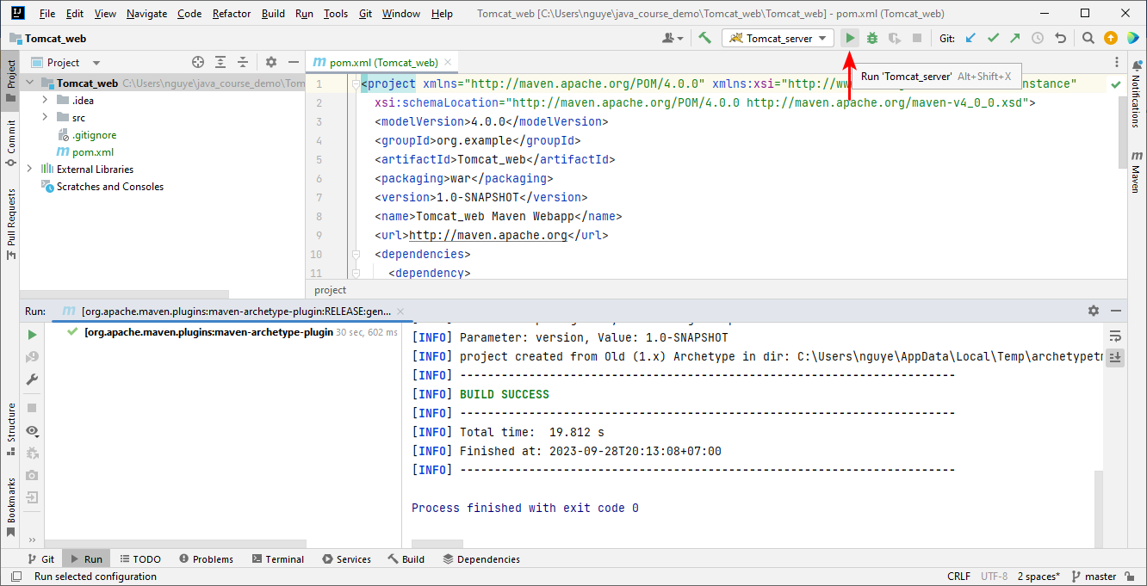

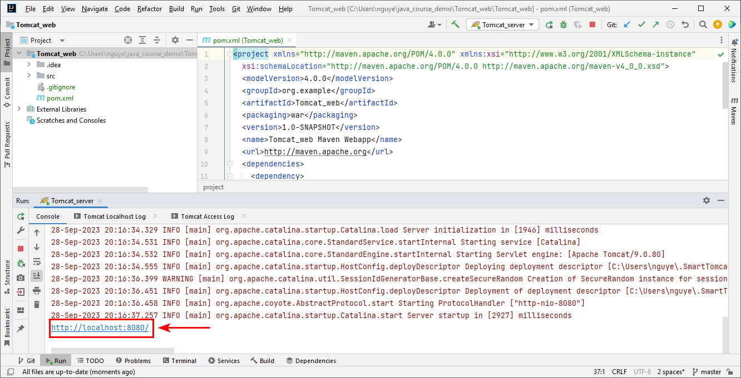

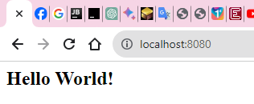

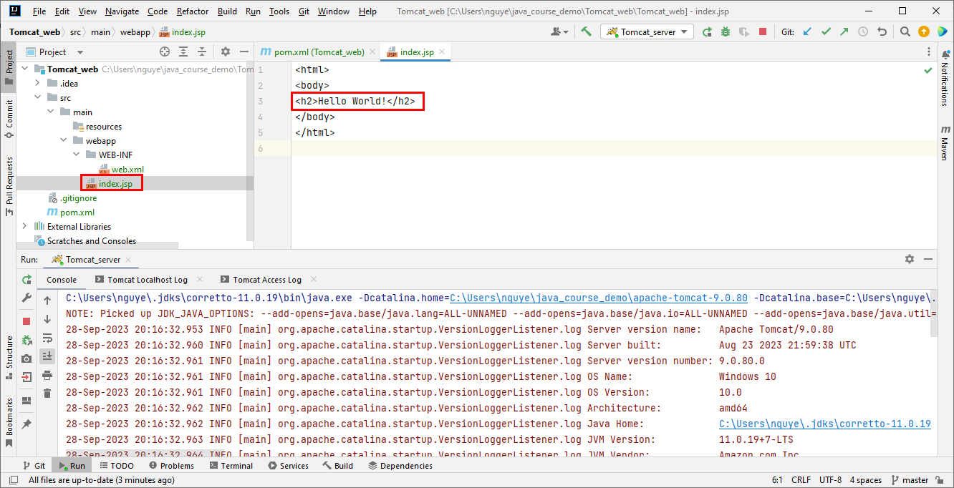

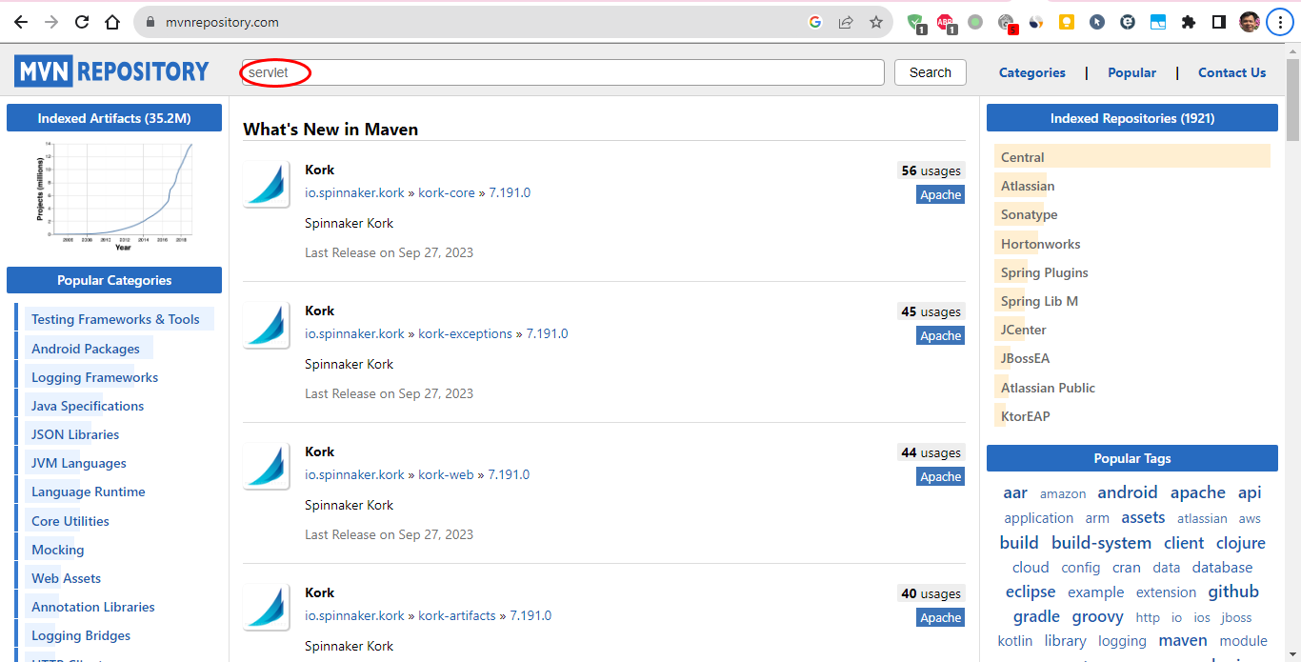

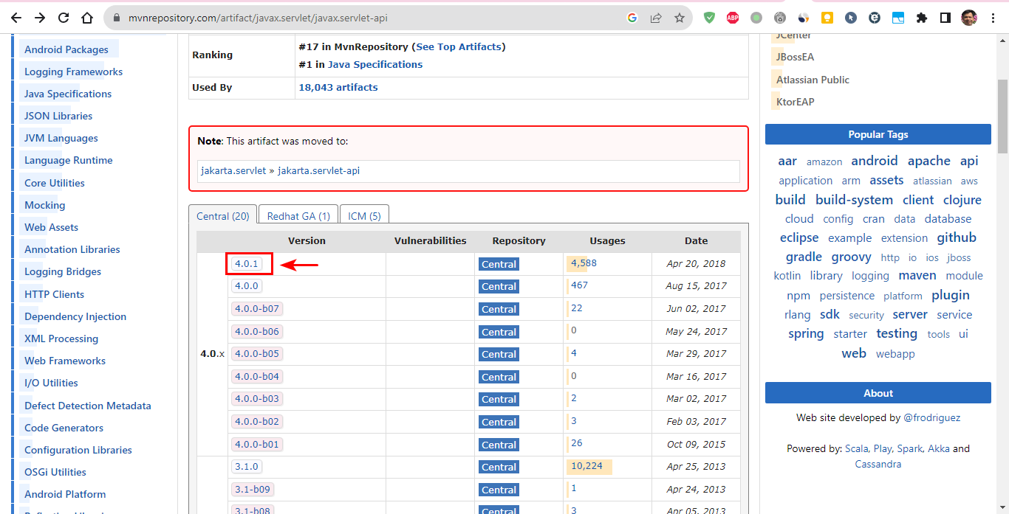

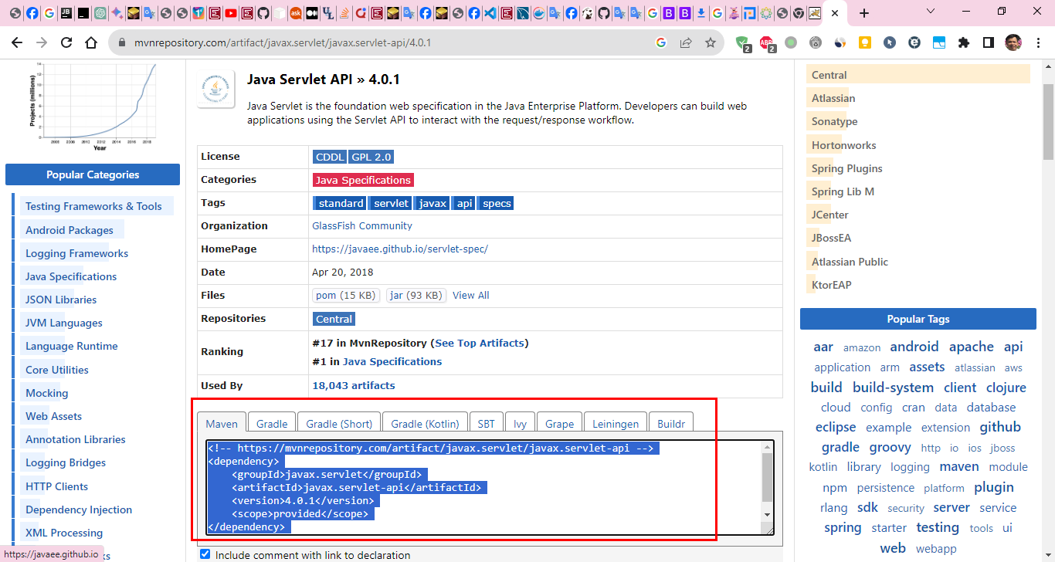

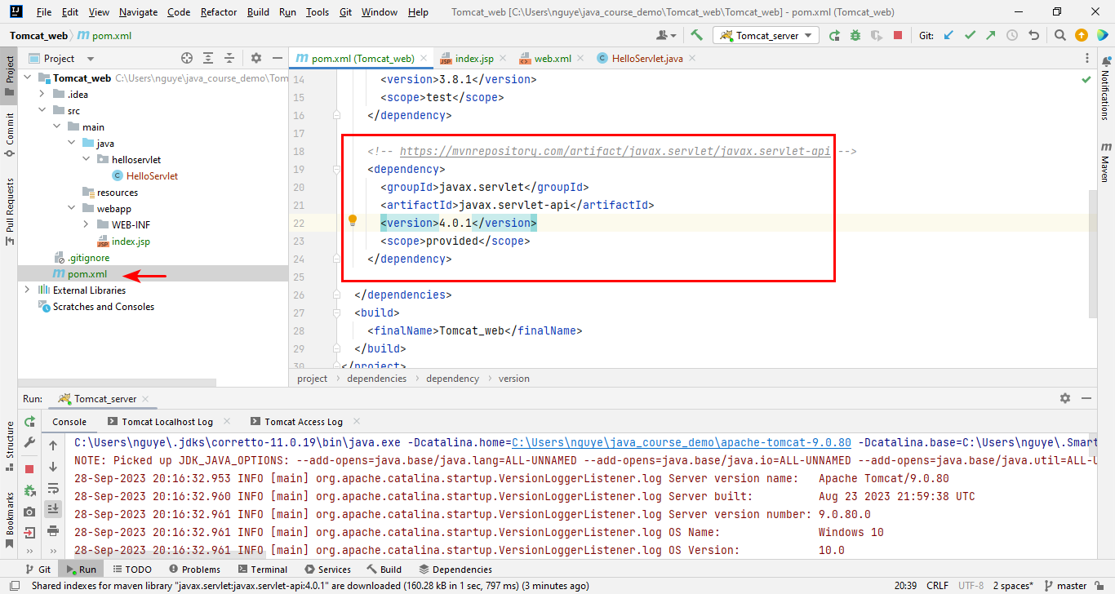

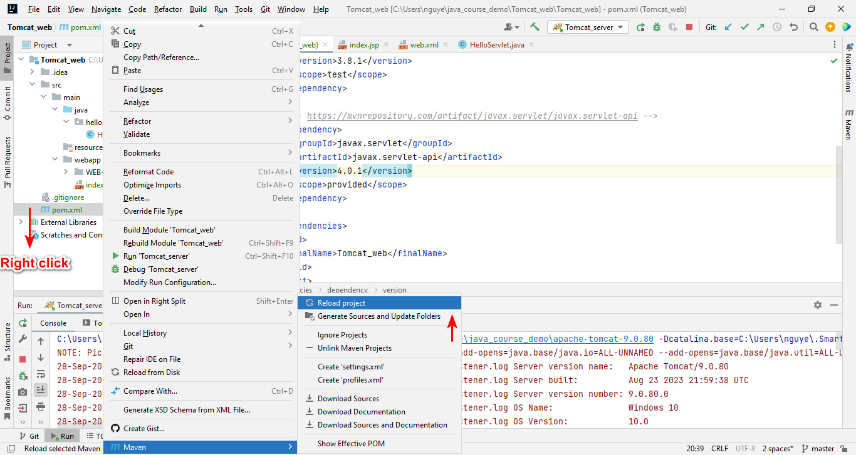

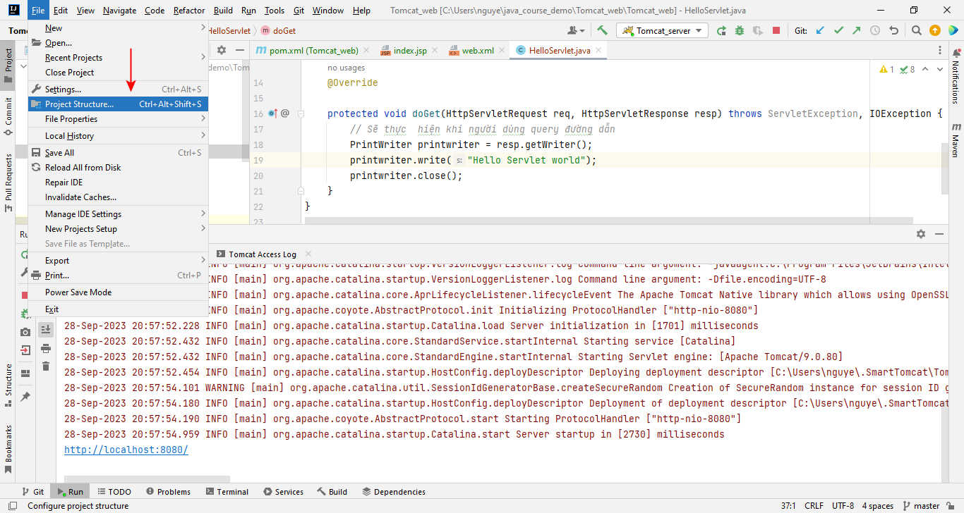

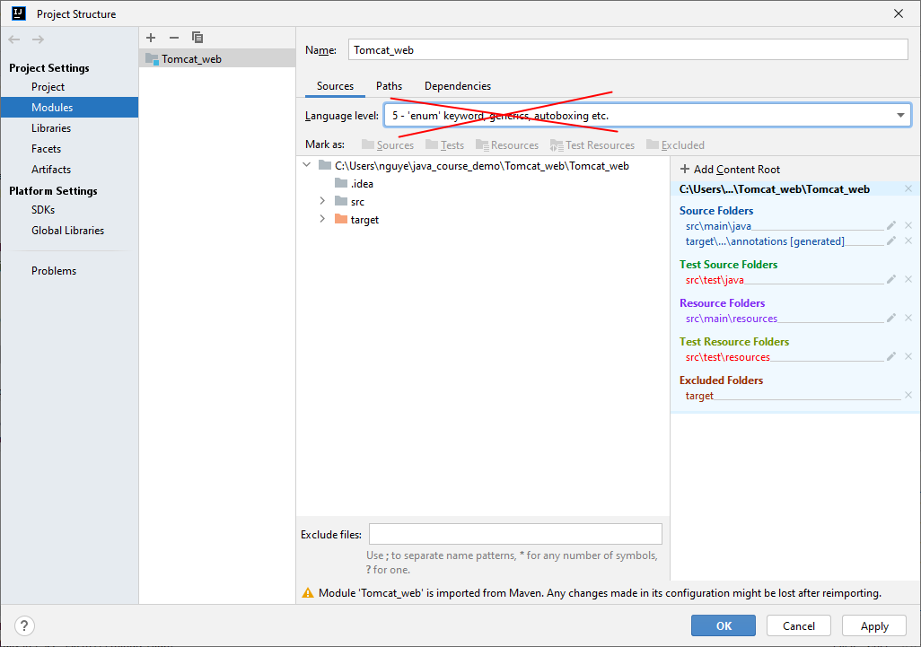

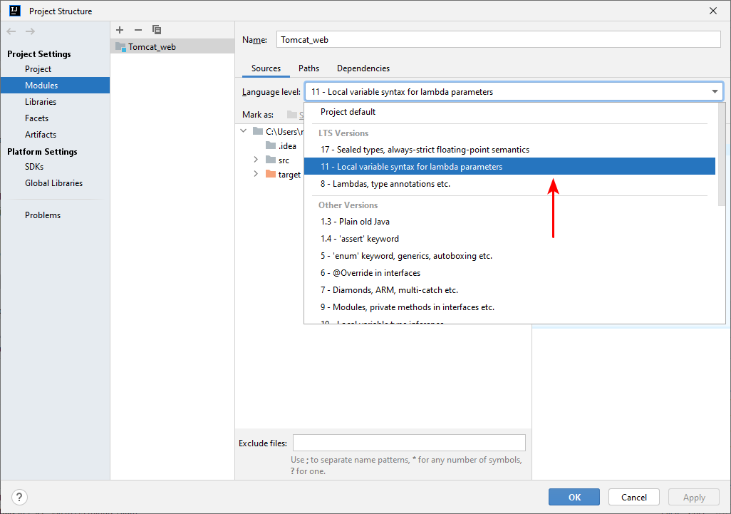

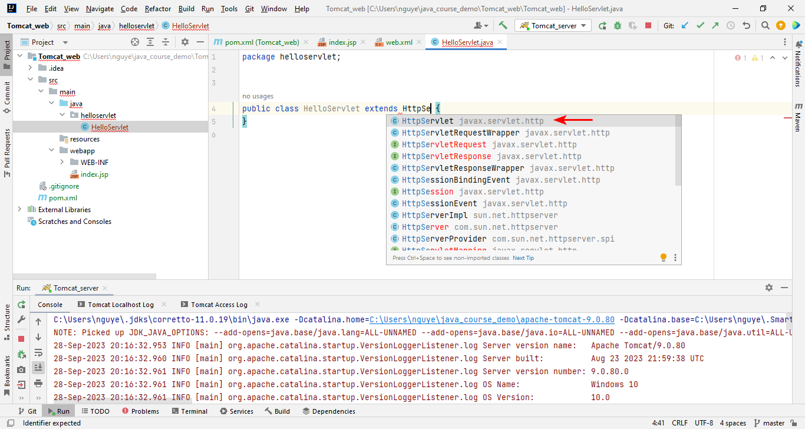

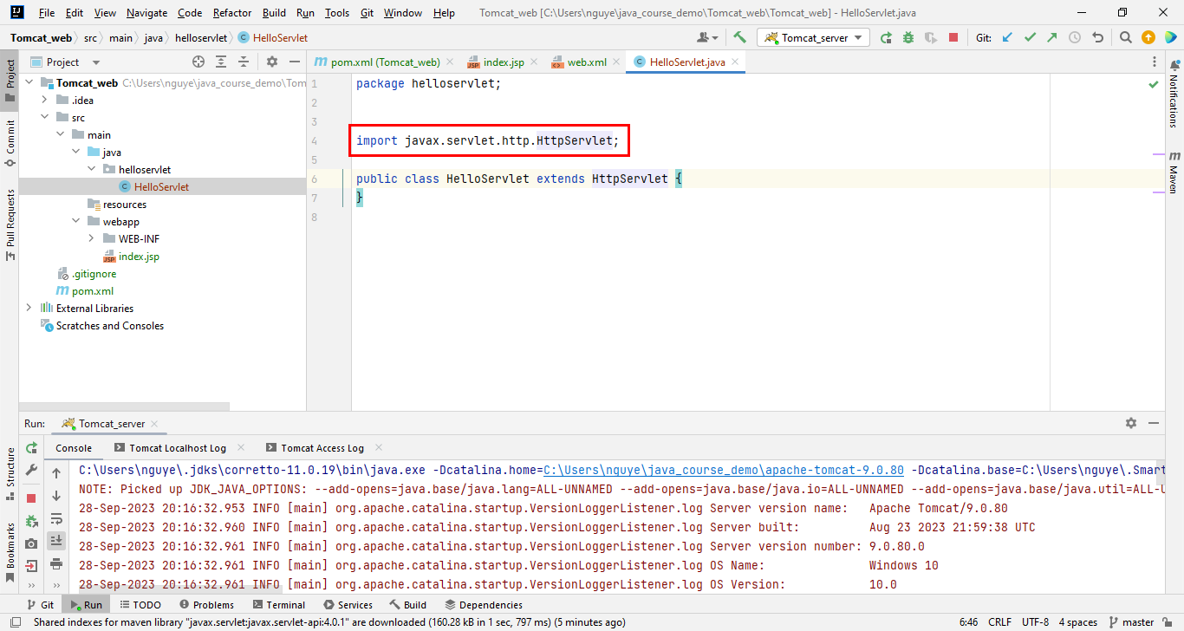

package helloservlet;  
  
import javax.servlet.ServletException;  
import javax.servlet.http.HttpServlet;  
import javax.servlet.http.HttpServletRequest;  
import javax.servlet.http.HttpServletResponse;  
import java.io.IOException;  
import java.io.PrintWriter;  
import javax.servlet.annotation.WebServlet;  
  
@WebServlet(name = "helloServlet", urlPatterns = {"/hello"})  
public class HelloServlet extends HttpServlet {  
 *// GET, POST => Methods cách thức client gọi đường dẫn* @Override  
  
 protected void doGet(HttpServletRequest req, HttpServletResponse resp) throws ServletException, IOException {  
 *// Sẽ thực hiện khi người dùng query đường dẫn* PrintWriter printwriter = resp.getWriter();  
 printwriter.write("Hello Servlet");  
 printwriter.close();  
 }  
}

1. **Configure the Tomcat Server for Your Project**:
   * Once your project is open, right-click on the project name in the left pane and choose **Open Module Settings** (or press **F4**).

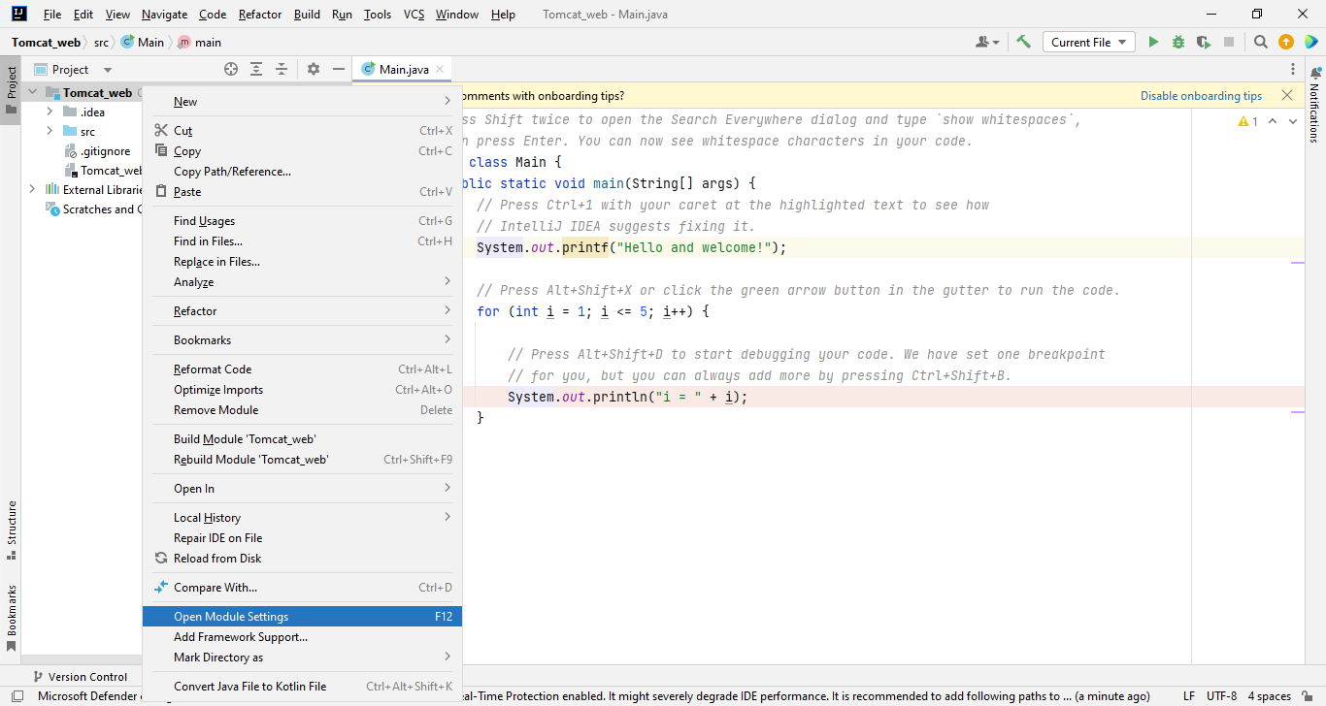

* + Click on **Facets** → **Web**.
  + In the right pane, ensure that the correct version of Tomcat is selected for the **Deployment Descriptors**.
  + Click **OK**.
  + Now, go to the **Run** → **Edit Configurations** menu.
  + Click on the **+** button and select **Tomcat Server** → **Local**.
  + In the **Server** tab, ensure that the correct Tomcat version is selected.
  + In the **Deployment** tab, add your artifact (usually the **.war** file) for deployment.
  + Click **OK**.

1. **Run Your Project**: With the server configuration set up, you can now run your project. Click on the green play button (or **Shift + F10**), and IntelliJ IDEA will start the Tomcat server and deploy your application.

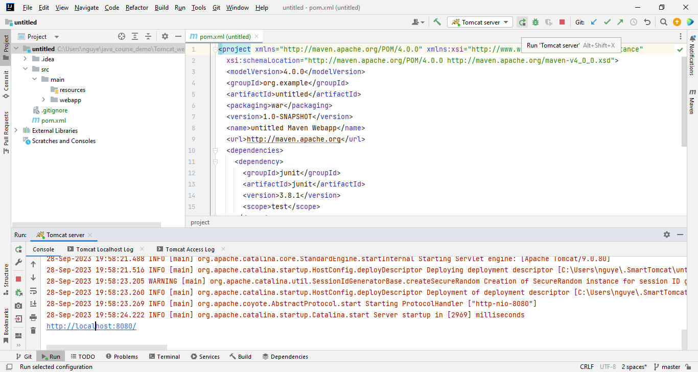

1. **Access Your Application**: Open a web browser and navigate to [**http://localhost:8080/**](http://localhost:8080/) to access your application running on the Tomcat server.

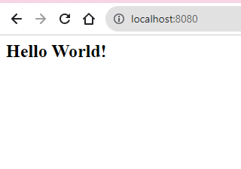

Steps to install Tomcat tarball file to IntelliJ IDEA 2023:

1. Download the Tomcat tar file (apache-tomcat-9.0.80.tar) from the official website.
2. Create a new directory for Tomcat.
3. Extract the Tomcat tar file to the directory you created in step 2.
4. Open IntelliJ IDEA.
5. Go to File > Settings > Plugins.
6. Click the + button and select Install plugin from disk.
7. Select the Smart Tomcat plugin and click Install.

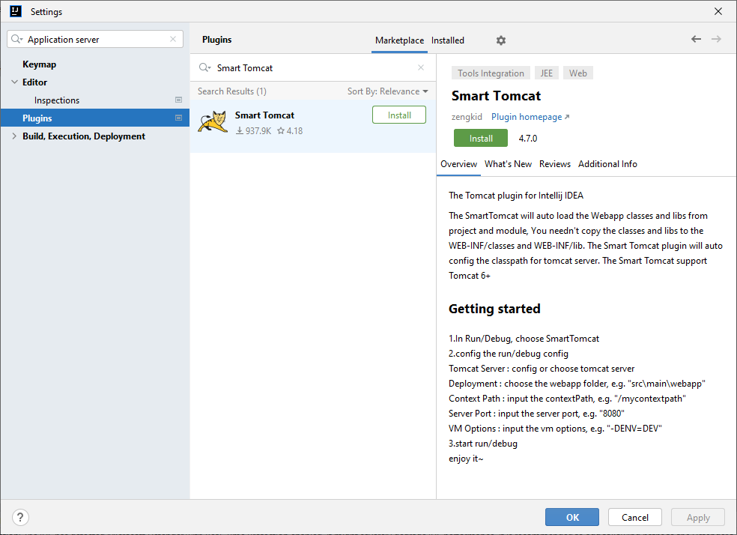

1. Once the plugin is installed, restart IntelliJ IDEA.
2. To create a new Tomcat server configuration, go to Run > Edit Configurations.

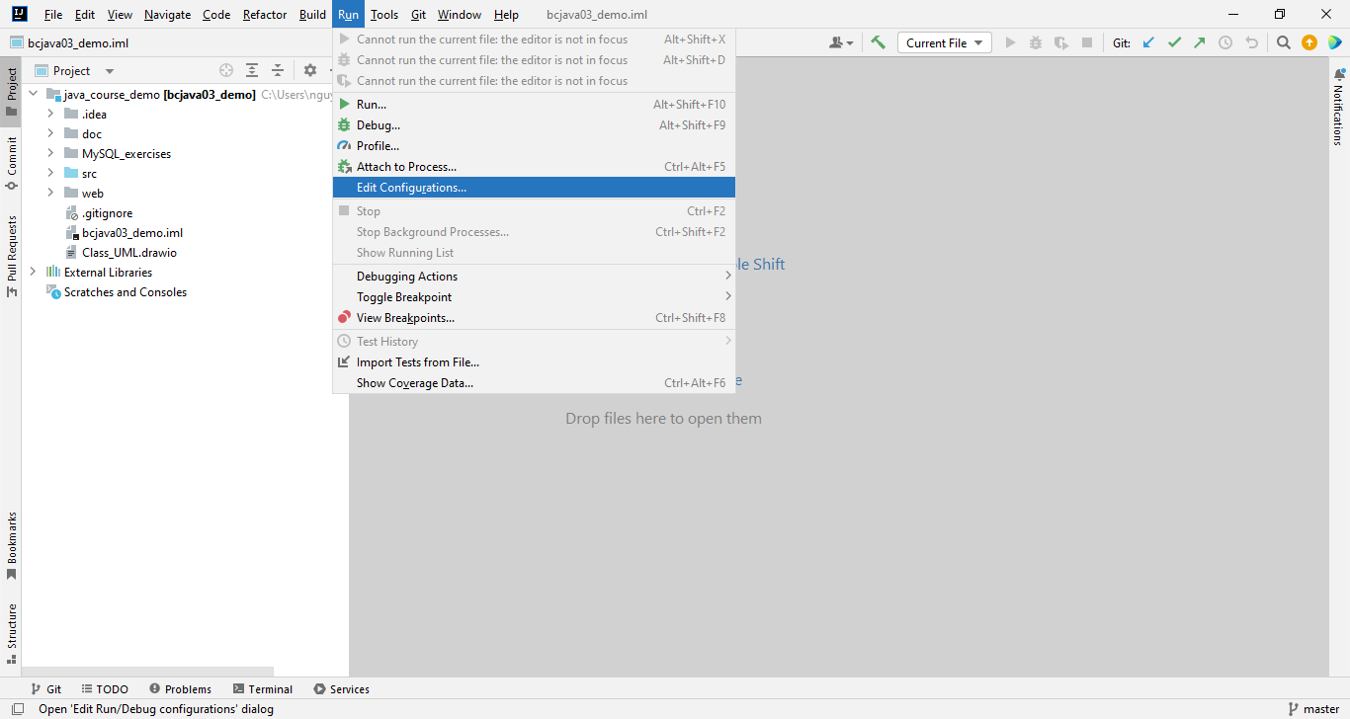

1. Click the + button and select Tomcat Server.

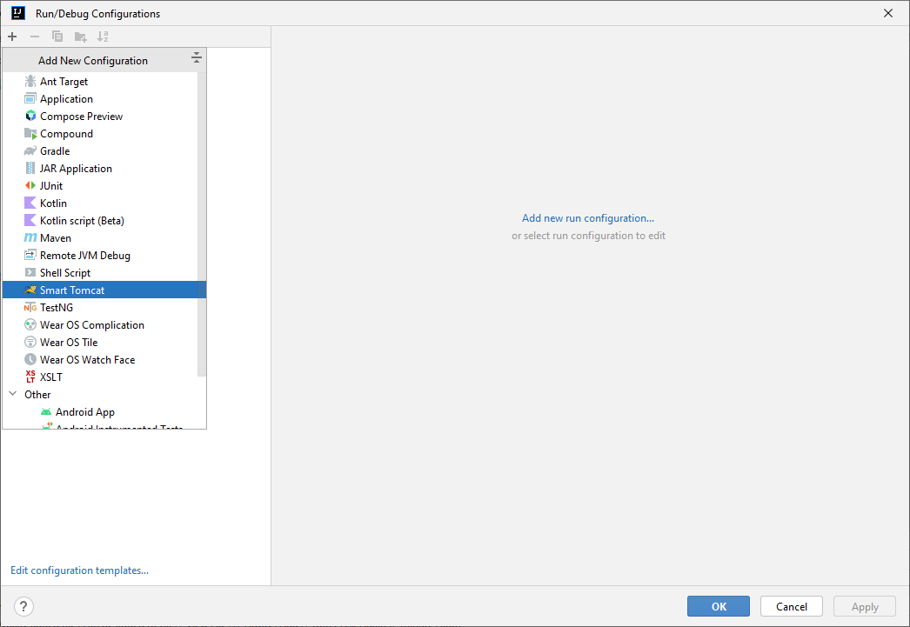

1. Give the configuration a name and select the Tomcat directory you created in step 2.

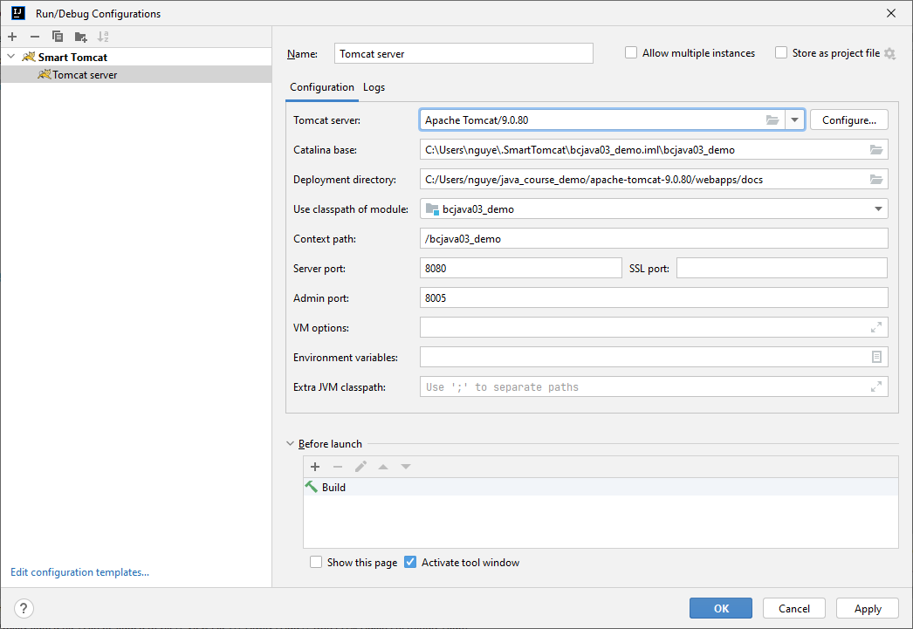

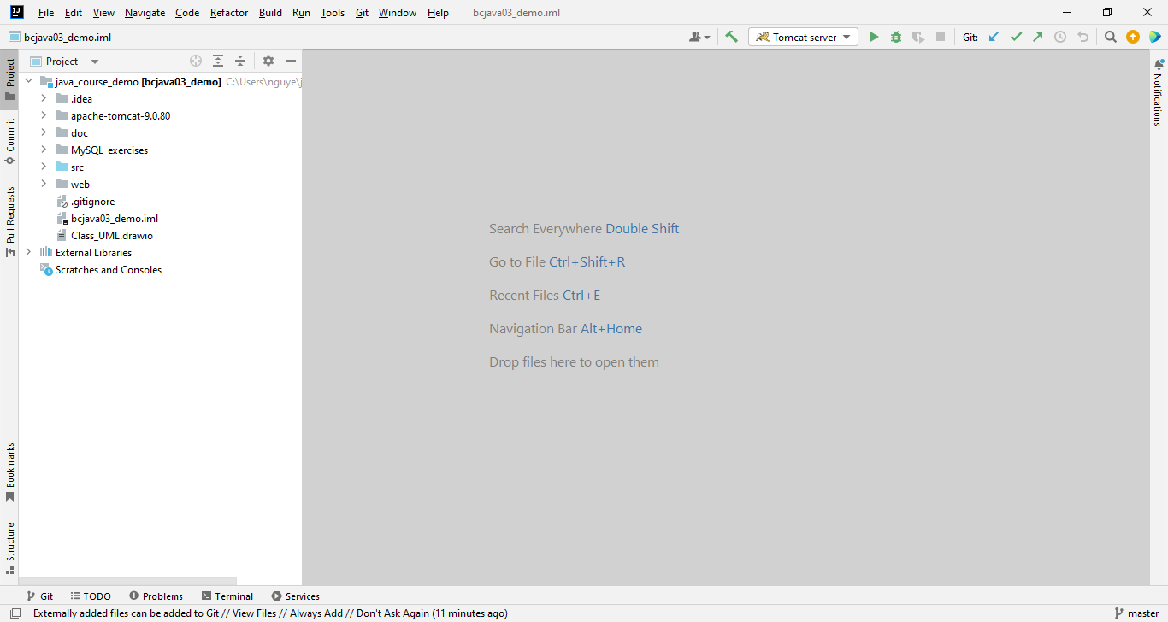

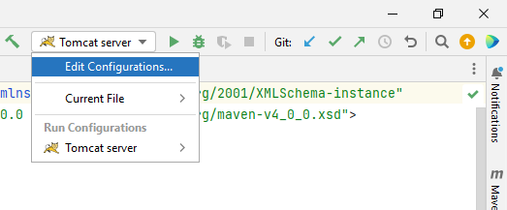

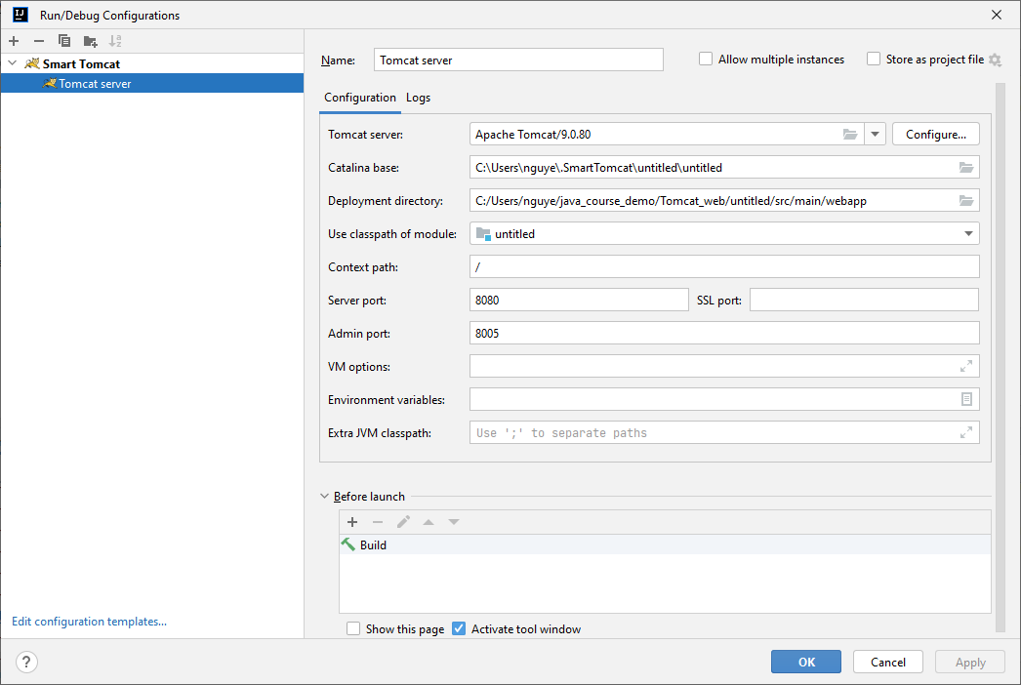

1. Click OK to save the configuration.
2. To start the Tomcat server, click the Run button.

Note: If you are using a firewall, you may need to open the port that Tomcat is using (typically port 8080).

Once you have installed Tomcat and created a server configuration, you can deploy your web applications to Tomcat by following these steps:

1. In IntelliJ IDEA, open the web application project that you want to deploy.
2. Right-click the project and select Run > Run 'project_name'.
3. In the Run/Debug Configuration dialog box, select the Tomcat server configuration that you created in step 11.
4. Click OK to run the web application.

Note: The first time you deploy a web application to Tomcat, you may need to create a new deployment configuration. To do this, follow these steps:

1. In the Run/Debug Configuration dialog box, click the + button and select Deployment.
2. Give the configuration a name and select the web application project that you want to deploy.
3. Click OK to save the configuration.

Once you have created a deployment configuration, you can deploy the web application by right-clicking the deployment configuration and selecting Run.